Title of Assignment: Continuous Assessment Project

Name of Candidate: David Robert Clarke

Degree Program: MSc Computer Science

Lecturer: Dr J.A.Bullinaria

Name of Institution: School of Computer Science
The University of Birmingham

Date of Submission: 15/01/2003

Table of Contents
Table of Contents 2
Abstract 3
Introduction 3
Design and Methodology 3
Results and Analysis 7
Discovering Best Values for η and α 7
Investigation, Varying the Number of Hidden Units 12

Abstract

Detailed in this assignment is the implementation and analysis of Multi-Layer Feed Forward Neural Network An implementation of a multi-layer perceptron using back-propagation with momentum; analysing its performance as it relates to (1) the learning rate (2) the regularisation term (3) number of units in the hidden layer is discussed. The most useful network that was analysed had 20 hidden units and performed best when it had a learning rate of 0.025 and momentum 0.05. A discussion is generated detailing how varying the learning rate, moment and number of units in the hidden layer affects the performance of the network.

Introduction

The objective of this mini-project is to gain practical experience in running and optimising a neural network simulation.

Design and Methodology

The mini-project requested that a multi-layer perceptrons would need to be used in the analysis of given training and test data. Single perceptrons (Single-Layer Feed-forward Neural Networks) have one input and one output layer of processing units. They can only cope with linearly separable problems, simple logic operations such as NOT, AND and OR.

1
1
1
1
-1
w_{ij}
i
Out_{j}
Out_{i}
θ_{i}
j
-0.5
1.5
0.5

Out_{j} = sgn( ∑out_{i}w_{ij} - θ_{i} ) NOT AND OR

- Single Layer Perceptron

Multi-layer perceptrons (MLPs or Multi-Layer Feed-forward Neural Networks) have one input, one output, and one or more hidden layers of processing units. No feed-back connections. The hidden layers sit between the input and output layers, and thus are hidden from the outside world. They are used because they are able to cope with non-linearly separable problems. MLPs usually have 2 layers (the input layer is layer 0), more layers can be added but for most practical purposes two layers are sufficient.

w_{jk}⁽²⁾
n = 2
n = 1
n = 0
ninputs
nhidden
noutputs
w_{ij}⁽¹⁾
out_{k}⁽²⁾ = f( ∑out_{j}⁽¹⁾w_{jk}⁽²⁾)
out_{j}⁽¹⁾ = f( ∑out_{i}⁽⁰⁾w_{ij}⁽¹⁾)
out_{i}⁽⁰⁾ = in_{i}
- Multi-Layer Perceptrons

If the network outputs are non-binary (as is the case for this experiment), then it is appropriate to have a linear output activation function rather than a sigmoid. The sigmoidal activation function is used on the hidden layers; it is differentiable and appropriately required in order for true gradient descent to be performed.

The aim of the neural network is for it to adjust its network weights w in order to minimise the sum-squared error function.

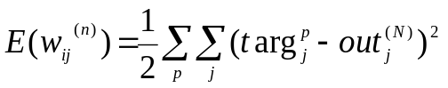

This is done by a series of gradient descent weight updates

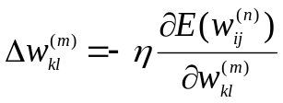

The learning algorithm automatically adjusts the outputs out_{j}^{(n)} of the earlier (hidden) layers so they form appropriate intermediate (hidden) representations.
By deriving the Back-Propagation algorithm, it can be seen that the weight changes at the first layer take on the same form as the final layer, but the error is back-propagated from each of the output units via the weights.

A compromise that will smooth the behaviour of the batch updates, without slowing down the learning too much, is to update the weights with the moving average of each training pattern. A momentum term (α) is simply added, which is the weight changes from the previous step times.
Momentum is a regularisation technique that encourages smoother network mappings by adding a penalty term to the standard sum squared error.

E_{reg} = E_{sse} + αX

α controls the trade-off between reducing the error E_{sse} and increasing the smoothing. This modifies the gradient descent weight updates so

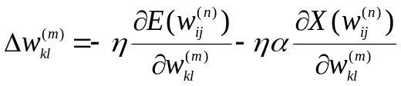

If α is zero then we have standard batch training. As α increases to 1, each step includes contributions from previous the previous training patterns. Usually the learning rate η will need to be decreased as α is increases so that the step sizes don’t get too large.

Hence α will need to be less than 1

A multi-layer perceptron trained with the back propagation algorithm learns in stages, moving from the realisation of fairly simple to more complex mapping functions as the training session progresses. This is demonstrated by the fact that the mean-square error decreases with an increasing number of epochs during training: it starts with a large value, then decreases rapidly and then decreases slowly as the network makes it way to a local minimum on the error surface. With good generalisation the goal, it is very difficult to figure out when it is best to stop training. It is possible for the network to end up over fitting the training data if the training session is not stopped at the right point.
The training data is used to train the network, the training session is then stopped after 1 epoch, and then the network is tested on the validation subset after each period of training. The periodic estimation-followed by- validation process proceeds as follows:

- After a period of training, the synaptic weights and bias levels of the multilayer perceptron are all fixed, and the network is operated in it’s forward mode. The validation error is thus measured for each example in the validation subset.
- When the validation phase is completed, the training is resumed to another period and the process is repeated.

Mean – squared error
Number of epochs
0
Test Data
Training Data
  - Illustration of Early Stopping

One potential problem with the idea of stopping early is that the validation error may go up and down numerous times during training. The safest approach is generally to train to convergence (or at least until it is clear that the validation error is unlikely to fall again).

Actual Minima
Local Minima
Mean – squared error
Number of epochs
0
Test Data
Training Data
  - Approaches to Stopping Early

The following method was followed and completed:

- A feed-forward neural network with one hidden layer of 20 sigmoidal units and an output layer of linear units was set up using the Java SNNS neural network simulator.
- The neural network was trained using back-propagation. The back-propagation learning rate η and momentum α were found by trying a range of values and plotting the corresponding graphs that resulted in consistently fast training. The resulting values were called η_{best} and α_{best}.
- The training and generalisation errors were plotted against each other, using the momentum α_{best} and learning rate η_{best}/2.
- The number of hidden units were then varied (whilst keeping the learning parameters fixed), and saw how the results in (3) were affected.

Results and Analysis
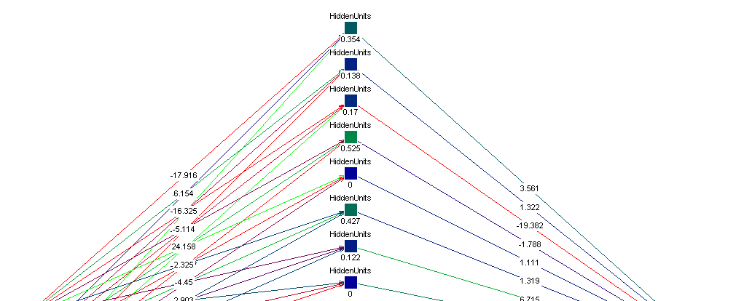
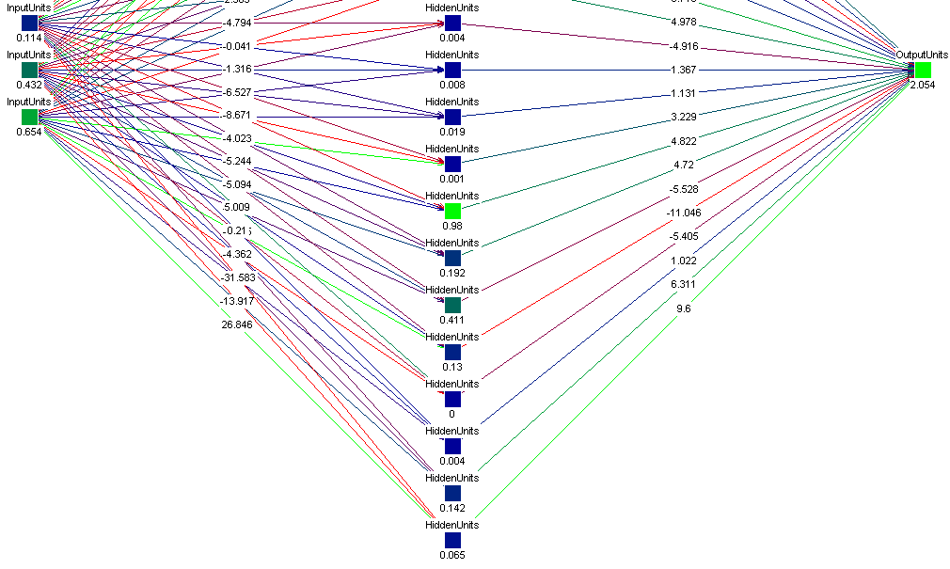
  - Feed-forward neural network with one hidden layer of 20 sigmoidal units and an output layer of linear units

The validation data had a total of 100 input and output patterns whilst the test data had 200. The data sets necessitated a network with 3 input units and 1 output unit. Without these network parameters the network would not be able to operate.

Discovering Best Values for η and α

For each combination of learning rate and momentum, the network was trained for between 30,000 - 50,000 epochs. By choosing these training/validation scale limits it was easier to judge the point where the validation sample diverged from the training sample i.e. where over fitting of the data began. To check for consistency of results, each network was tested 3 times with the same values for learning rate and momentum. The only difference in results can arise from the randomness of the synaptic weight initialisations. An initial test was undertaken that looked at how the network reacted to different learning rates. Once a boundary for η values was established another more effective test could be carried out taking into consideration the momentum term.

η | Stopped (No of Epochs)
0.01 | 3500
0.05 | 1000-1500, 4000-4500
0.1 | 1000 – 1500
>0.1 | Indiscernible
- How the number of Epochs varies with varying η

From the initial results it could be seen that using a learning rate greater than 0.1 would be unfeasible because the results were too erratic. The next test took the previous feasible η values and implemented the momentum term. Which ever η and α values would make the network stop under-fitting the earliest and consistently produced good results would be declared the best. If the results were inconsistent with each other then a different η and α value would be used for testing.

 | η | α | Stopped (No of Epochs)
 | η | α | Result 1 | Result 2 | Result 3
TEST 1 | 0.1 | 0.01 | 6000 | 1000 | 11000
TEST 2 | 0.05 | 0.05 | 1000 | 2000 | 1000
TEST 3 | 0.01 | 0.1 | 6000 | 4000 | 5000
- How the number of Epochs varies with varying η and α

TEST 1: η = 0.1, α = 0.01
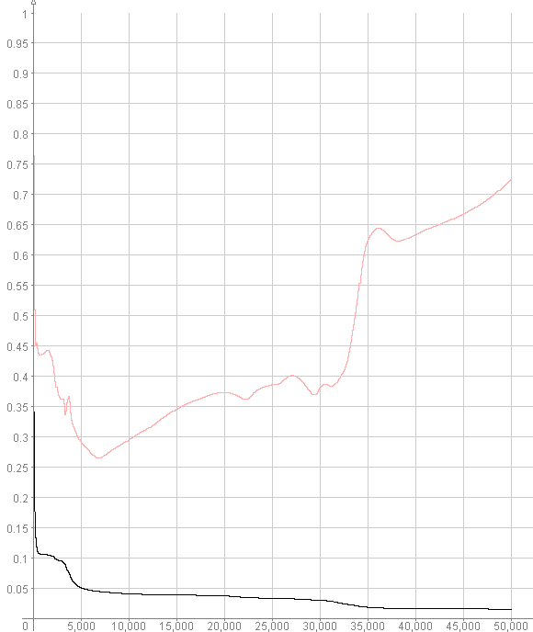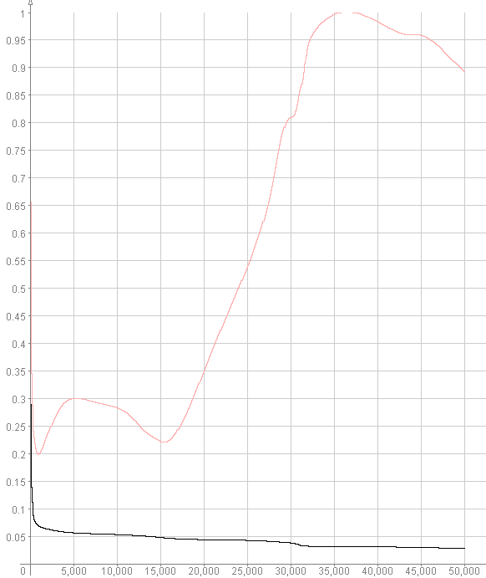
- Result 1, Stopped Training after 6000 epochs Graph 2. Result 2, Stopped Training after 1000 epochs

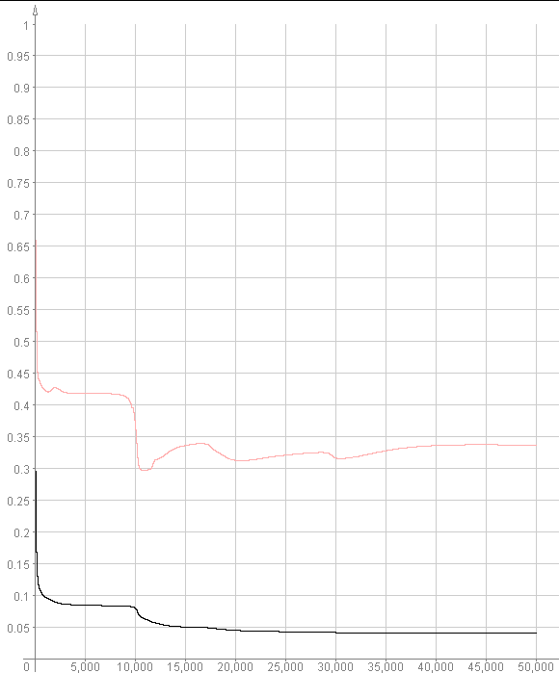
- Result 3, Stopped training after 11000 epochs
TEST 2: η = 0.05, α = 0.05

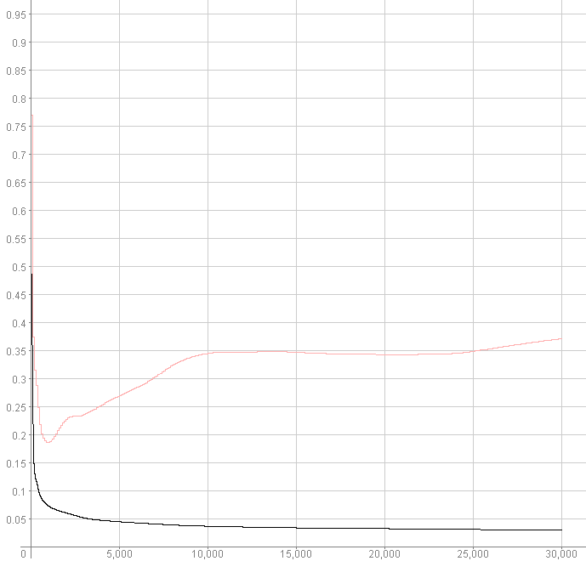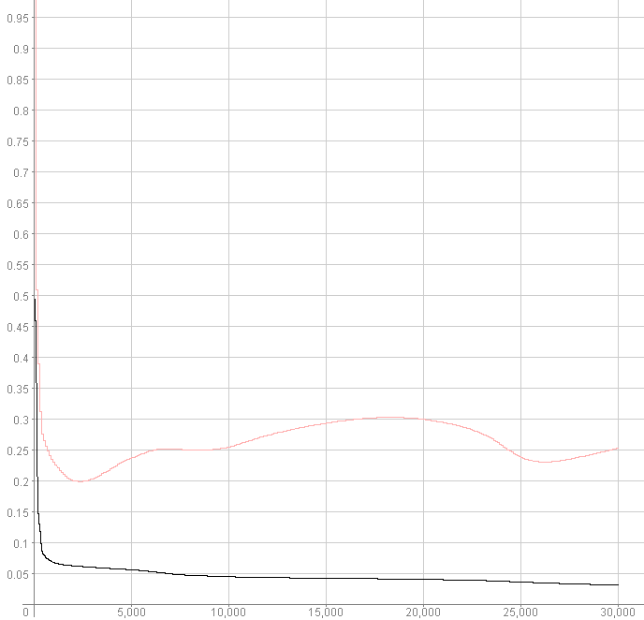
- Result 1, Stopped Training after 1000 epochs Graph 5. Result 2, Stopped Training after 2000 epochs

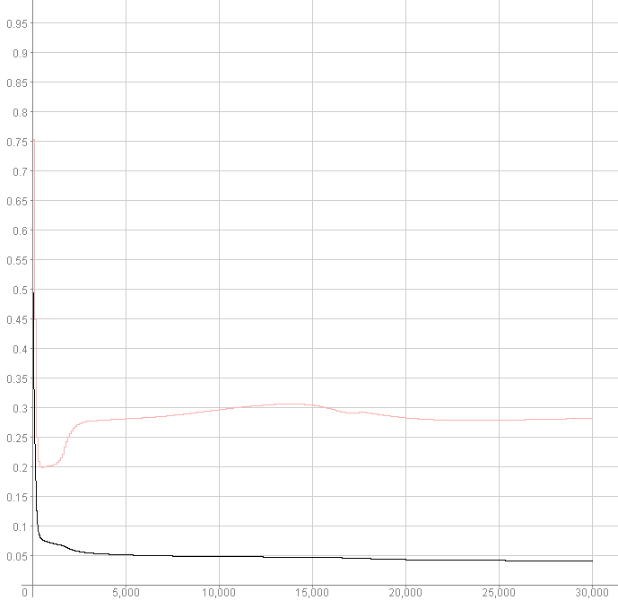
- Result 3, Stopped Training after 1000 epochs

Tests 3: η = 0.01, α = 0.1

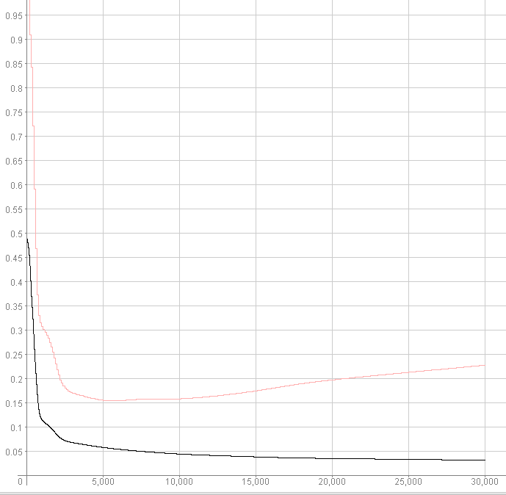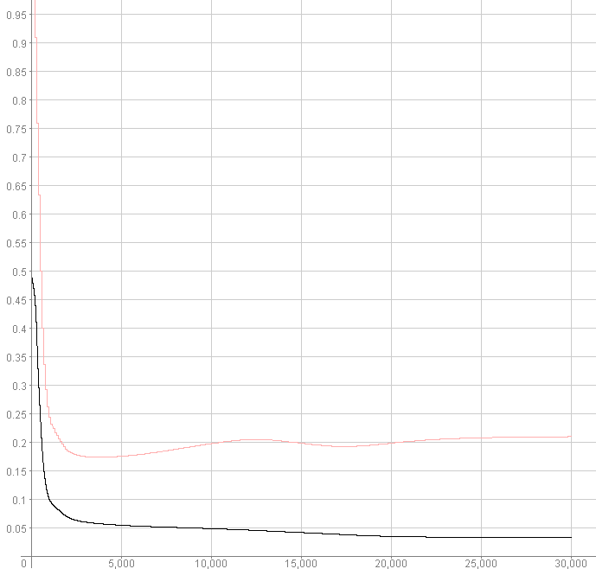
- Result 1, Stopped Training after 6000 epochs Graph 8. Result 2, Stopped Training after 4000 epochs

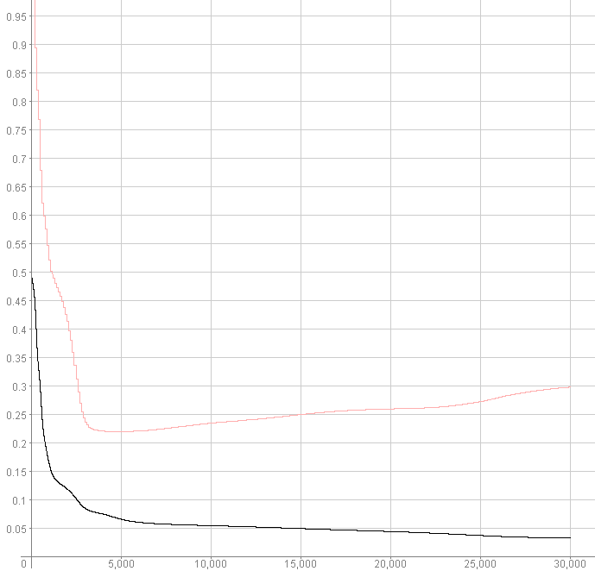
- Result 3, Stopped Training after 5000 epochs

In TEST1 (Graphs 1 – 3) where the regularisation parameter α is low (0.01) and the learning rate η is high (0.1), a variable number of epochs passes (1000 - 11000) before over fitting of the training data occurs. When over fitting occurs, because the regularisation term is small the error function appears erratic in nature.
In TEST3 (Graphs 7 – 9) the network parameters are reversed, α equals 0.1 and η equals 0.01. The network updates are very smooth, the stopping points are consistent and the training error is low. However, because this is a test for the fastest training of the network, these parameters are not the best to use.
It can be seen in TEST2 (Graphs 4 – 6) that when η = 0.05 and α = 0.05 network training is consistently much faster (over fitting begins to occur after approximately 1000 epochs) and the validation function is relatively smooth in comparison to TEST3. From these 3 tests it can be seen that the best parameters for η and α are:

η_{best} = 0.05
α_{best} = 0.05

Investigation, Varying the Number of Hidden Units

Shown below is a plot of the training and generalisation errors against the number of epochs using α_{best} (0.05) and learning rate η_{best}/2 (0.025). The hidden layer in the network was varied from 20 units down to 1unit. All of the proceeding tests were carried out over 100 epochs. This length of training would clearly show the extent to which over fitting occurs, or not as it is the case.

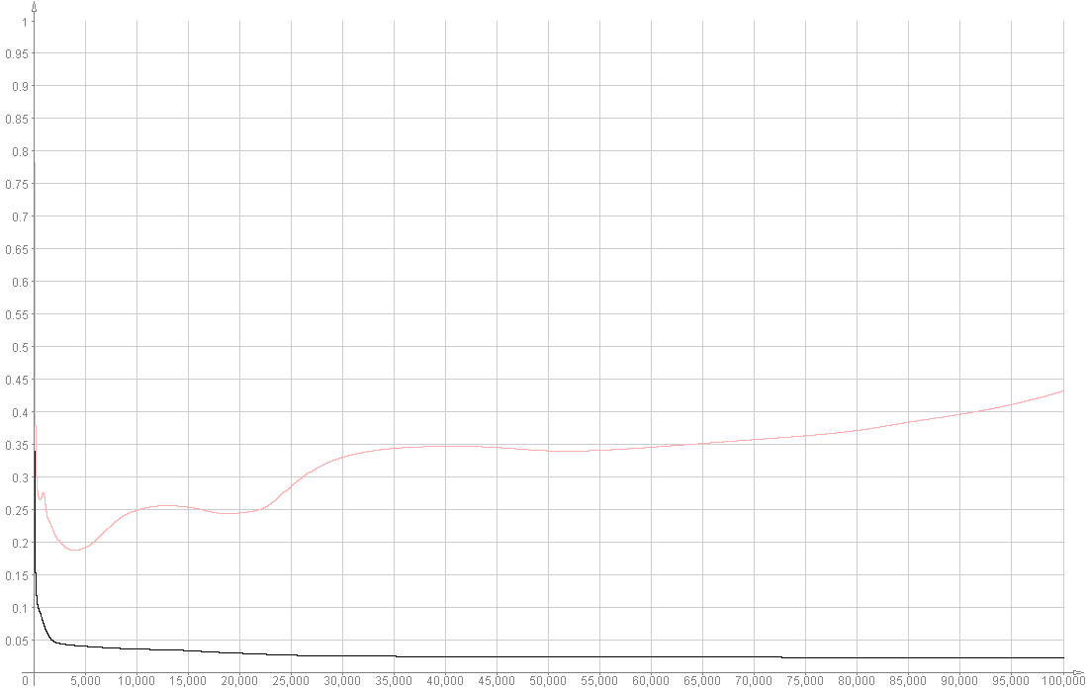
- Training and Generalisation Error vs. No. of Epochs for a network with 20 Hidden Units

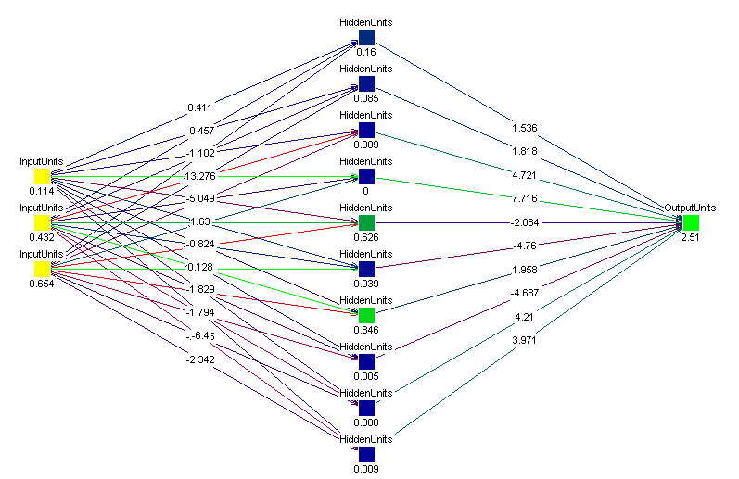
  - Network with 10 Hidden Units
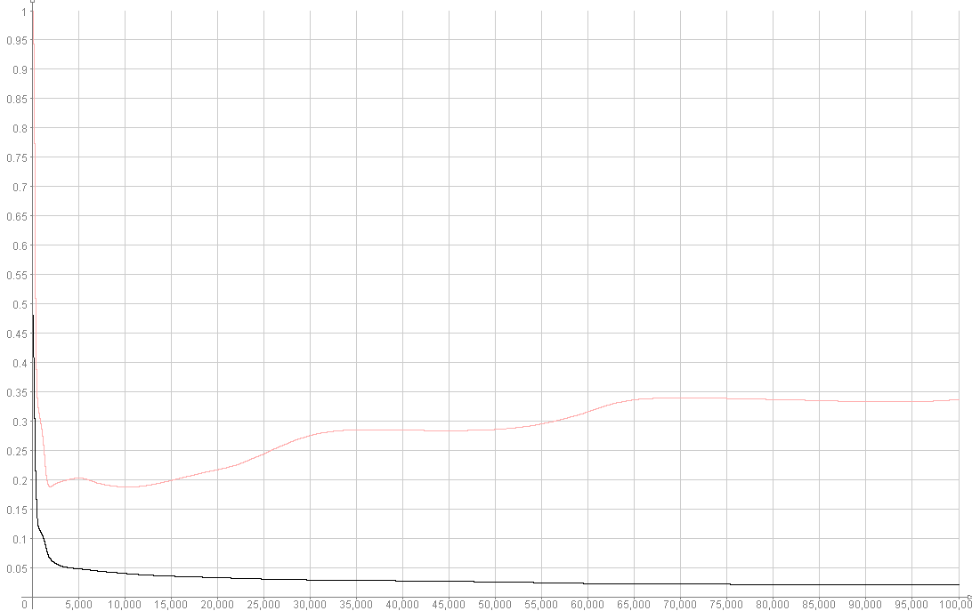
- Training and Generalisation Error vs. No. of Epochs for a network with 10 Hidden Units

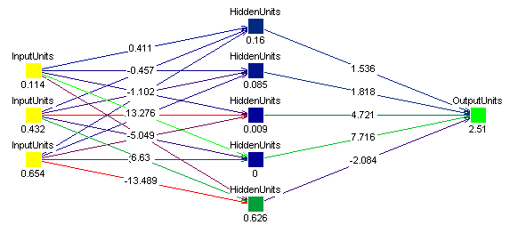
  - Network with 5 Hidden Units

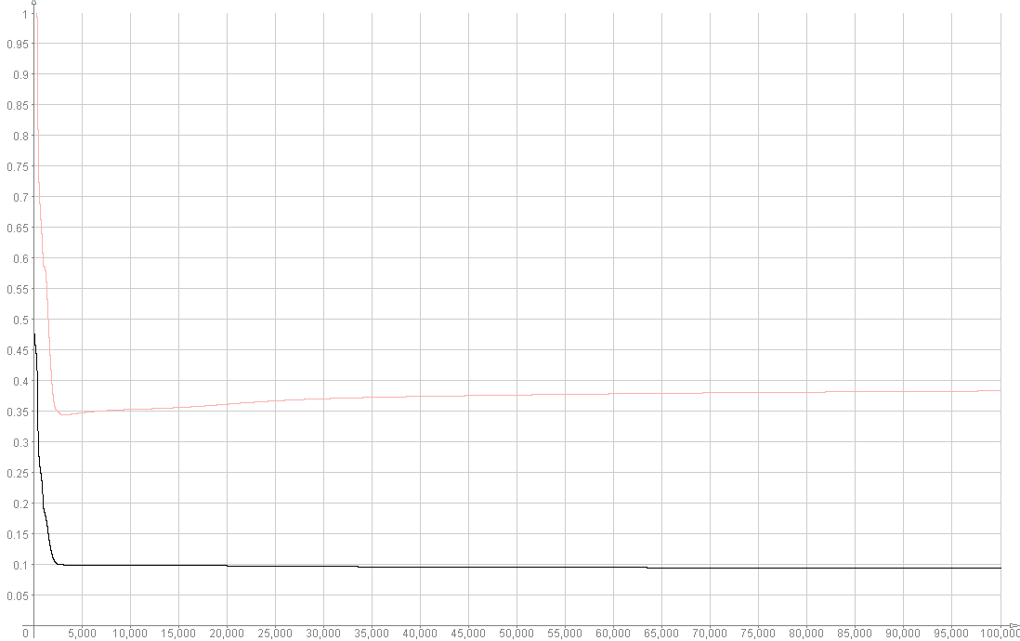
- Training and Generalisation Error vs. No. of Epochs for a network with 5 Hidden Units

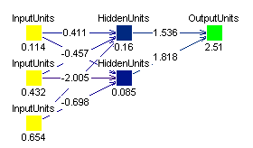
  - Network with 2 Hidden Units

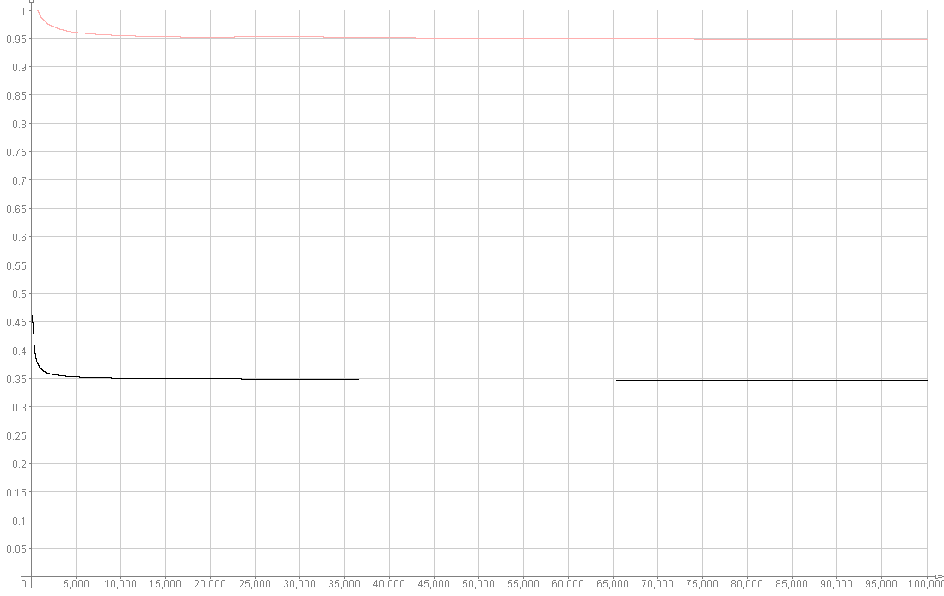
- Training and Generalisation Error vs. No. of Epochs for a network with 2 Hidden Units

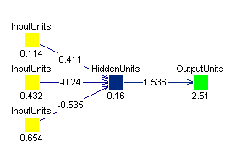
  - Network with 1 Hidden Unit

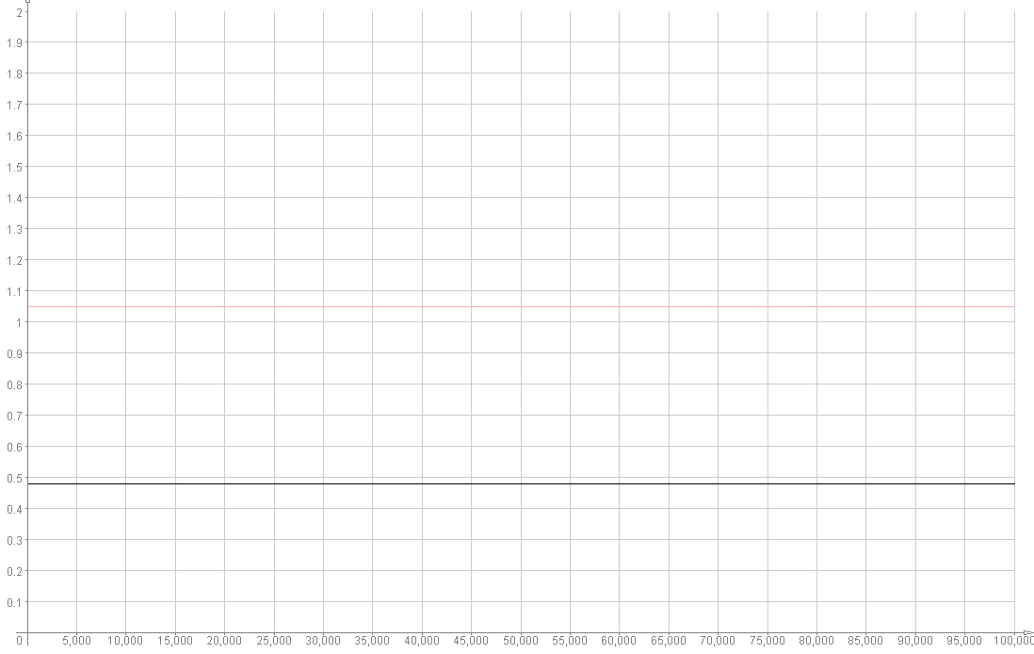
- Training and Generalisation Error vs. No. of Epochs for a network with 1 Hidden Unit

Taking a look at graphs 10 to 14, it can be seen that as the number of hidden units is decreased to a limit 5 under fitting (giving high bias) of the training data occurs. The mean square error between the validation and training data begins to increase. However, the point where over fitting occurs remains more or less the same.

Graphs 13 & 14 show that when the number of hidden units is decreased below the number of input units (3) the training and validation errors increase dramatically and over fitting doesn’t occur. It can be seen that when the network is tested with 1 hidden unit, the error curves were horizontal meaning the network did not learn.

Discussion and Conclusions

By increasing the momentum parameter α, the level of under fitting increased (higher bias level). This resulted in an error curve for the validation sample looking a lot smoother. However by increasing α the learning parameter η had to be decreased, else the network would take too long to get to get close to the minimum of the sum squared error function. The optimal parameters for α and η were 0.05 and 0.025 respectively. These were only optimal parameters for the given validation and training data.

The number of hidden units in the network would need to be increased if:

- Under fitting of the training data occurred for any value of η or α.
- The training and generalisation error is too high for any value of η or α.

In order for the network to learn there must be a sufficient number of hidden units i.e. the number of hidden units must be greater than the number of input units.
References

- Lecture notes for Intro to Neural Networks Course,
John A. Bullinaria, School of Computer Science, University of Birmingham, 2002

- Neural Networks, A Comprehensive Foundation
Simon Haykin

- Introduction to Neural Networks: Continuous Assessment Sheet
John A. Bullinaria, School of Computer Science, University of Birmingham, 2002

